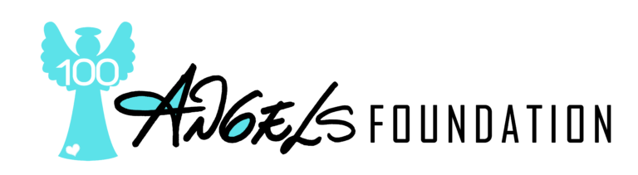

Donor Privacy Policy

September, 2022
As a humanitarian nonprofit organization, One Hundred Angels (OHA) places a high priority on protecting donors’ privacy. Below please find answers to our most commonly asked questions about donor privacy.

Do you share donor information with other organizations?
- We do not share or sell donors’ personal information to any other organizations. Nor do we send fundraising appeals on behalf of other organizations.
- If we disclose any personal information, we will offer donors the opportunity to consent to disclosure. We have never disclosed any personal information and have no plan to.
- We ensure that donors’ personal information will not be disclosed to state institutions and authorities except if required by law or other regulation.

What data do you collect from donors and how do you use it?
- Donations made online directly to OHA are secure. When you make a donation online, we ask for your name, address, phone, email address, and credit card information. We use your information to process your donation(s) and to verify credit card data. We use your email address to send your tax-deductible receipt(s) and to keep you informed about what we are doing through our publications. Your phone number is used only to contact you if we need to verify order information and occasionally to thank you for your contribution.
- For donations processed through a third-party service provider, our donors’ information will only be used for purposes necessary to process the donation.

How do I access or change my personal data with One Hundred Angels?
- We allow you to challenge the data that we hold about you and, where appropriate, you may have the data erased, rectified, amended or completed.
- You can write to One Hundred Angels at onehundredangels@icloud.com to request a change in your personal data.

How do I stop receiving correspondence from One Hundred Angels?
- OHA provides the option to unsubscribe to any email communication at the bottom of every online correspondence.
- You can write to One Hundred Angels at onehundredangels@icloud.com and request to be removed from our mailing lists.
- To opt out of receiving print correspondence from OHA, please send an email to onehundredangels@icloud.com or a letter to the following address:
One Hundred Angels Foundation
23233 N. Pima Road
Suite 113-129
Scottsdale, AZ 85255

What if your policy changes?
Our donor privacy policy is current as of the date above. If our practices change, we will immediately update the policy. Regardless of later updates, we will never use the information you submit under the current policy in a way not described in this notice without first providing you an opportunity to opt out or otherwise prevent that use.
Please email comments or questions about our donor privacy policy to onehundredangels@icloud.com

